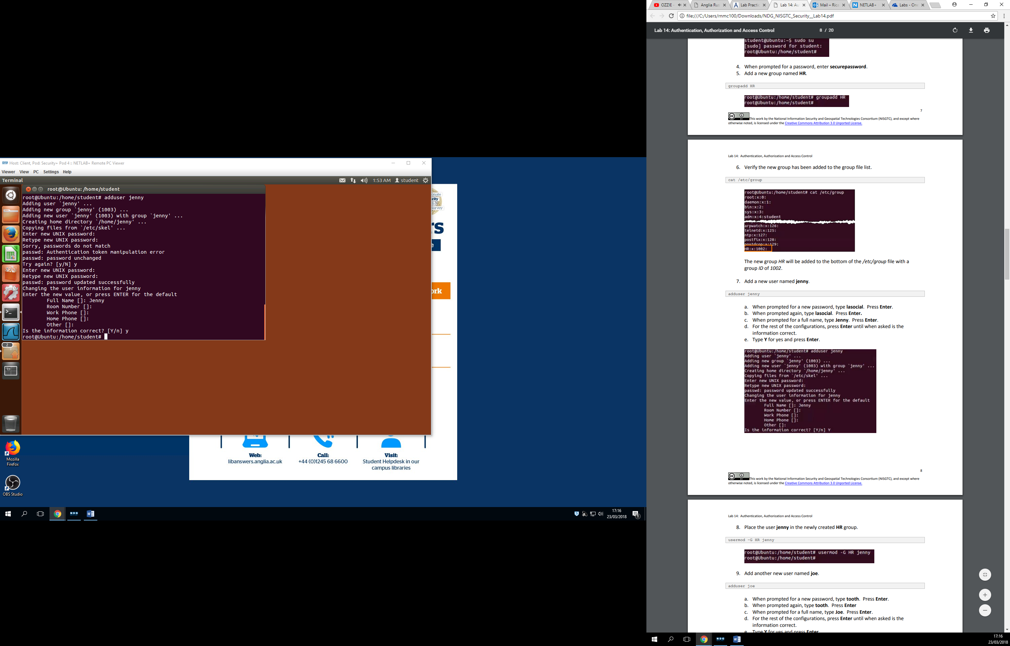

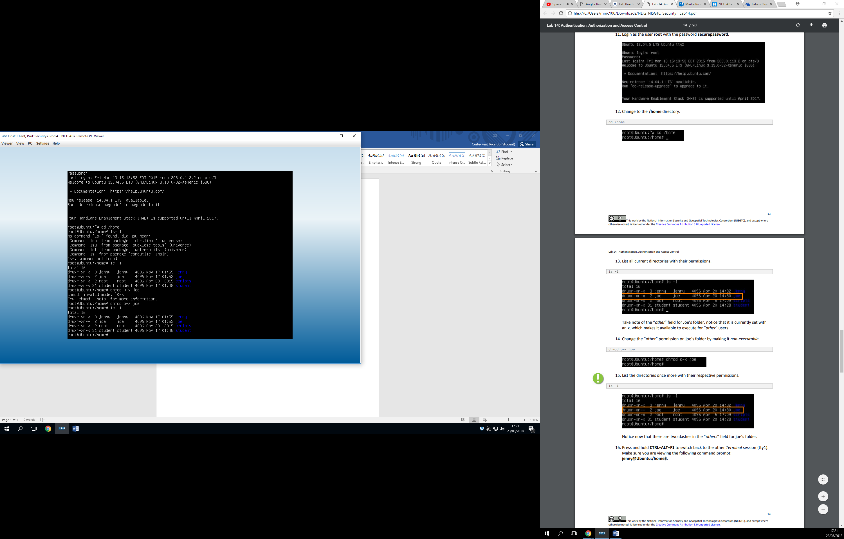

Here we gave joe proper permissions. When we logged in as jenny and tried to go in joes things, it said permission denied.